**STUDENT ATTENDANCE USING FACIAL RECOGNITION SYSTEM**

***This project is an automatic student attendance system using face recognition. The aim is to automate the process of attendance maintenance.***

**FACE RECOGNITION**

Face recognition is a biometric recognition technique. Biometric recognition is an information system that allows the identification of a person based on some of its main physiological and behavioural characteristics. Face recognition is a broad problem of identifying or verifying people in photographs and videos, a process comprised of detection, alignment, feature extraction, and a recognition task It has 4 steps which are:

* **Face Detection**
* **Data Gathering**
* **Data Comparison**
* **Face Recognition**

**TECHONLOGY USED**

* OPENCV
* TKINTER
* HAAR-CASCADE CLASSIFIER
* LocalBinaryPatternHistogram (LBPH) recognizer
* trainner.yml
* PIL

**HOW THE SYSTEM WORKS?**

This system works as the series of steps explained below:

* **DATA COLLECTION**:  
  The student interacts with the system through this Graphical User Interface (GUI) above. In the first step, the student has to enter his details (Name and Roll Number) which will be stored in a csv file **'StudentDetailss.csv'**.   
  After entering the details, the student will click on the **IMAGE CAPTURE** button which will take 50pictures of the student and store in the **TrainingImages** Folder.   
    
  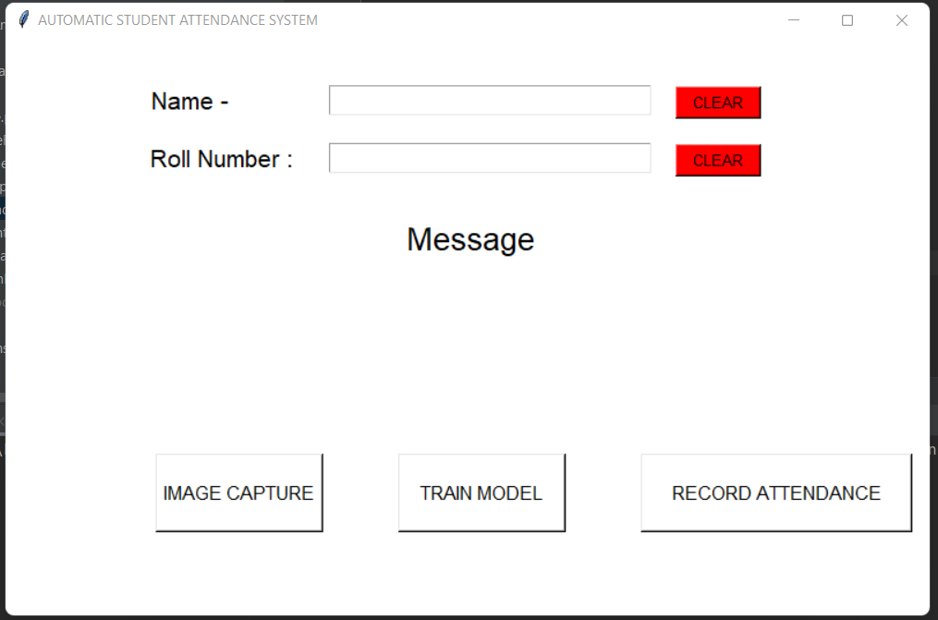  
  The **haar-cascadeclassifier** file is present to detect faces through the video stream where the student’s face will be captured.  
  The notification board will print out the student details after a successful data collection.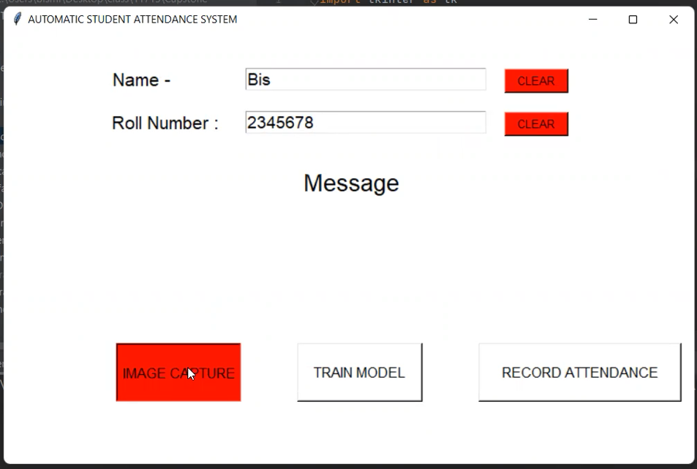

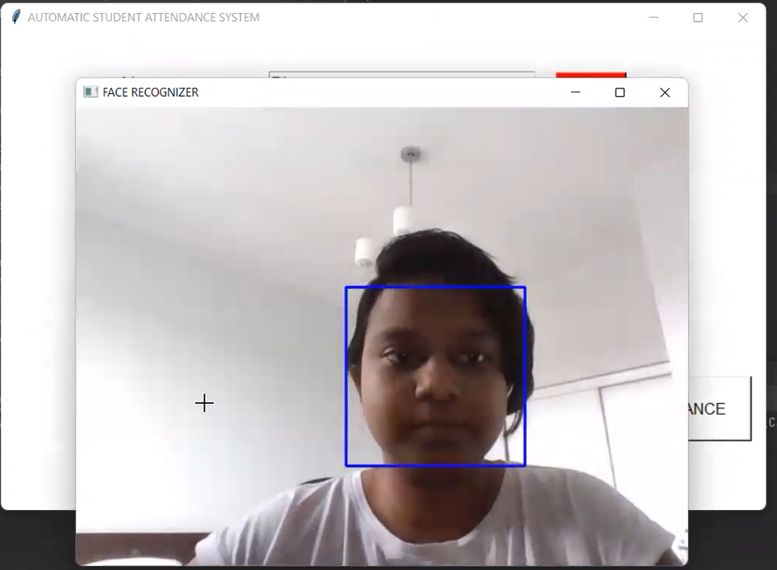

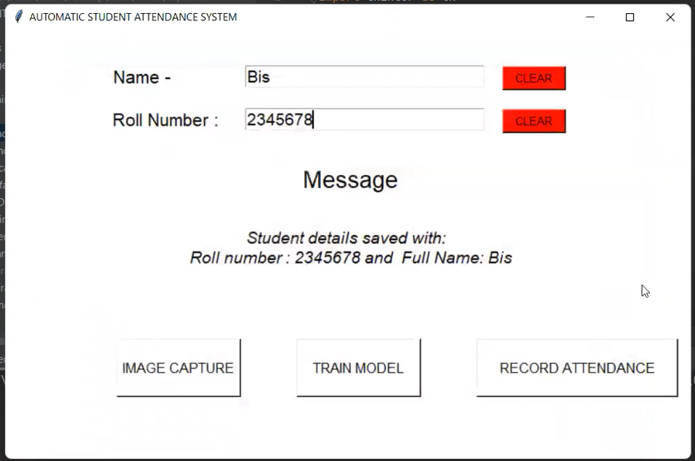

* **IMAGE TRAINED**The student has to click on the **TRAIN MODEL** button which will link his/her details and face features through the **LBPHrecognizer** to ease further face recognition, the recognizer will save the face features in the **trainner.yml** and "Image Trained" will be printed on the GUI notification board after the successful link.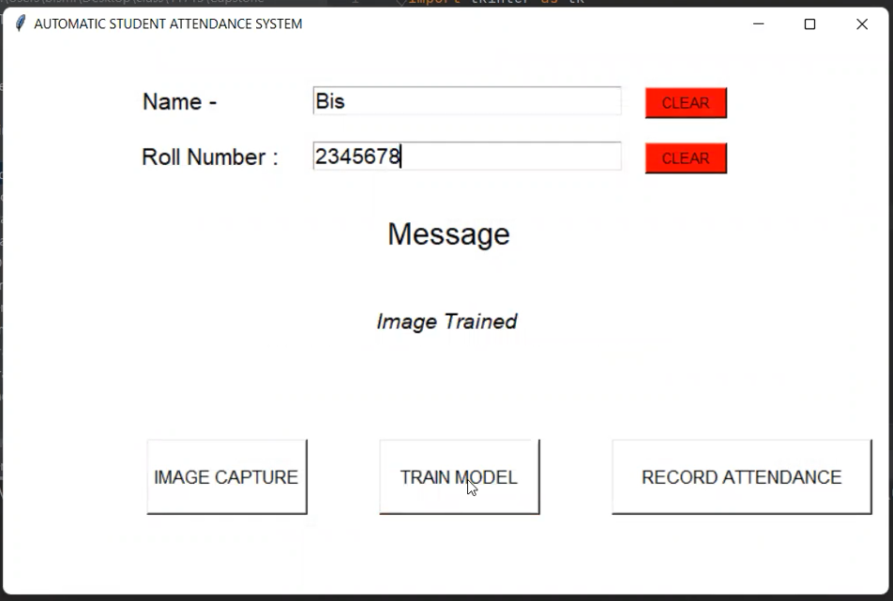
* **FACE TRACKING**The student has to click on the **RECORD ATTENDANCE** button to allow the face recognizer to track his/her face through a video stream, when the system will successfully recognize the student’s face then there will a notification saying "ATTENDANCE UPDATED AITH DETAILS”.   
  Simultaneously, a csv file **AttendanceFile.csv'** will be updated with the ID, NAME of the student and DATE and TIME at which his face has recognized.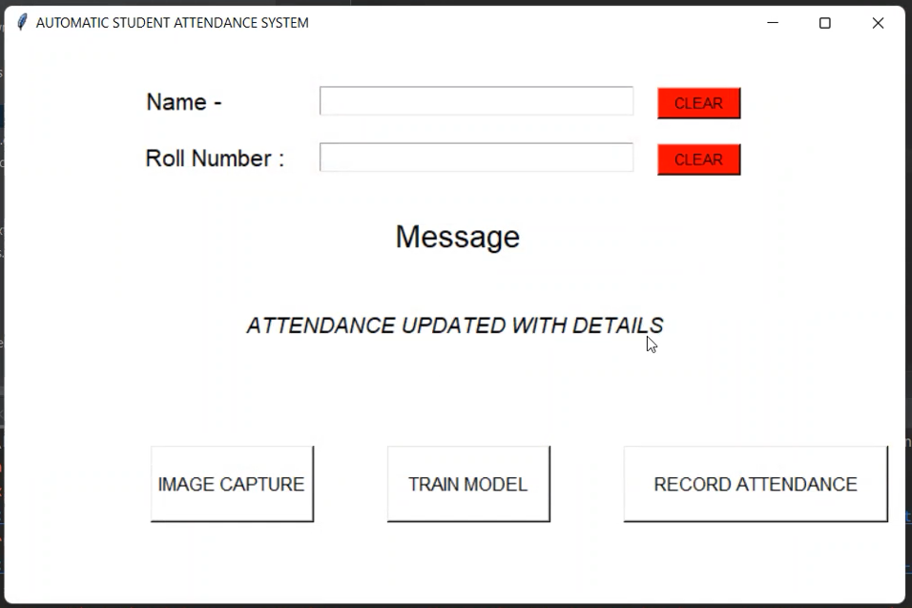  
    
  If the student is already not registered i.e., the ID will be Unknown then it will be printed out otherwise saying "ID UNKOWN, ATTENDANCE NOT UPDATED" will be printed out.   
  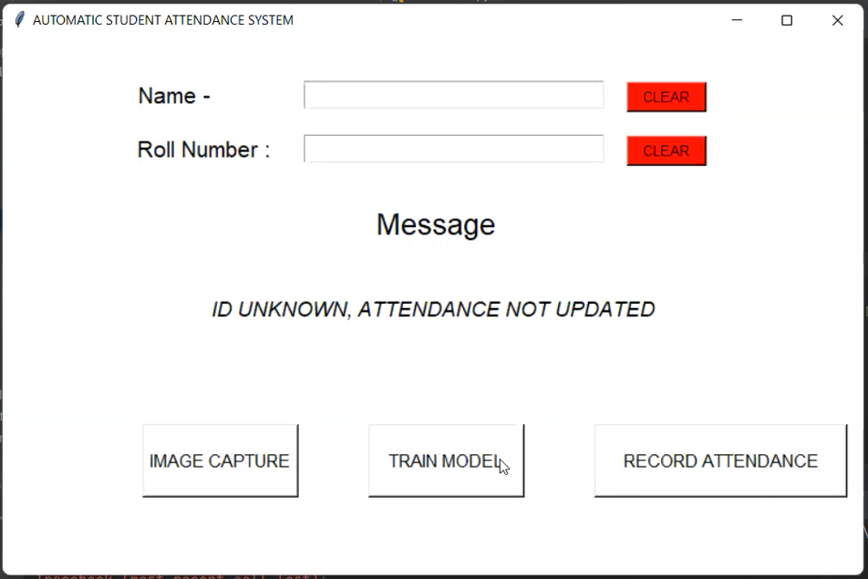

**FUTURE INSIGHTS**

* Creating a scope also to capture image and details for the unknown IDs during RECORD ATTENDANCE and get it validated to save into
* To align all the notifications with respect to font and wording
* To add log functions to better monitor the flow and also add exception handling more accurately .